Game Design Document

Fill up the following document

1. Write the title of your project.

Mario Game

1. What is the goal of the game?

Reach the Checkpoint and defeat the enemies.

1. Write a brief story of your game.

The mario has to cross the obstacle and reach the checkpoint by

Defeating the enemies .

1. Which are the playing characters of this game?

* Playing characters are the ones who respond to the user based on the input from the user.
* Cars, monkeys, dinos, wizards, etc., are the playing characters in the game.

|  |  |  |
| --- | --- | --- |
| Number | Character Name | What can this character do? |
| 1 | Mario | Move with the arrow keys and jump |
| 2 |  |  |
| 3 |  |  |
| 4 |  |  |
| 5 |  |  |
| 6 |  |  |
| 7 |  |  |
| 8 |  |  |

1. Which are the Non-Playing Characters of this game?

* Non-Playing characters are the ones that don't have an action or behavior when the user interacts with the game.
* Hurdles, stones, bananas, coins, etc., are non-playing characters in the game.

|  |  |  |
| --- | --- | --- |
| Number | Character Name | What can this character do? |
| 1 | obstacle | Still object |
| 2 | enemies | Can move around the map |
| 3 |  |  |
| 4 |  |  |
| 5 |  |  |
| 6 |  |  |
| 7 |  |  |
| 8 |  |  |

Draw your imagination of this game. What does this game look like?

* Draw the game either on your computer or on paper.
* Add images of the game scenes to show each of the playing and non-playing characters at least once.

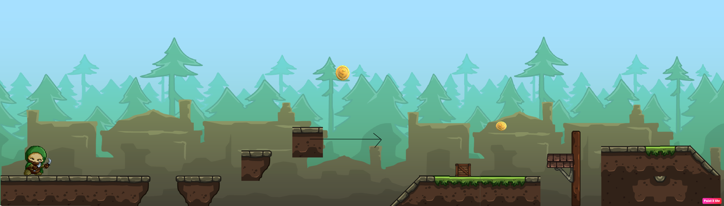

How do you plan to make your game engaging?

By adding challenges and making the difficulty level harder time by time.